Table of Contents

Design and list of requirements 2

Program requirements: 2

Design: 2

Rapid prototype sketches 3

Single Button layouts 3

Layout 1 3

Layout 2 3

Multiple Button layouts 4

Layout 1 4

Layout 2 4

# Design and list of requirements

The application for this student project should contain the following (may change over time), in an unorganized order:

## Program requirements:

* Buttons – Play, Stop/Pause, skip etcetera.
* Be able to play at least one audio sample (music, sounds etc.)
* Need to work on at least one platform, be it PC or mobile.

## Design:

* Should be intuitive to the user – Minimal interface.
* Could be thematic – Application used for relaxation (or something similar)?
* Designed to play specific files from the authors of the application – does not work like a standardized music player.

# Rapid prototype sketches

These sketches were done with the intention of visualizing initial ideas for the final product.

## Single Button layouts

Button transition between states (active/inactive):

### Layout 1

Thematic – Image used to illustrate the sound being played:

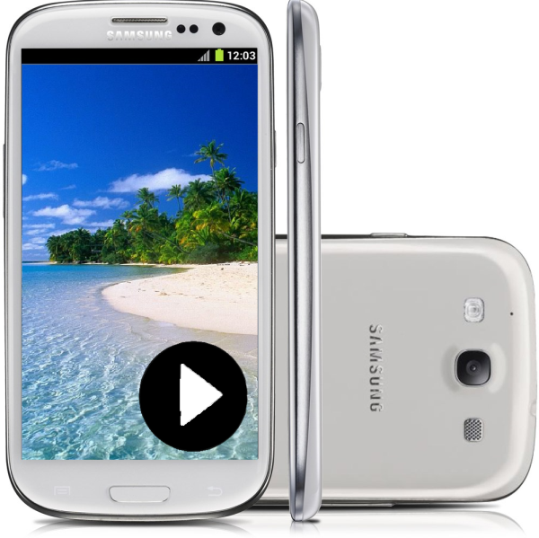 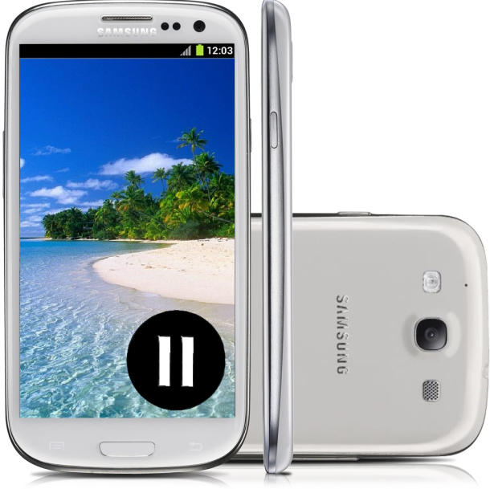

### Layout 2

Only one button is visible at a time.

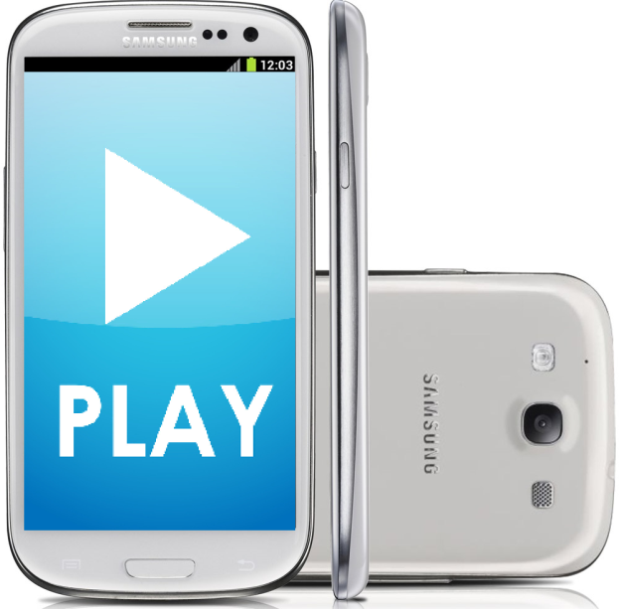

## Multiple Button layouts

### Layout 1

4 buttons button – Play, Stop/Pause, Forward and Backwards (skip).

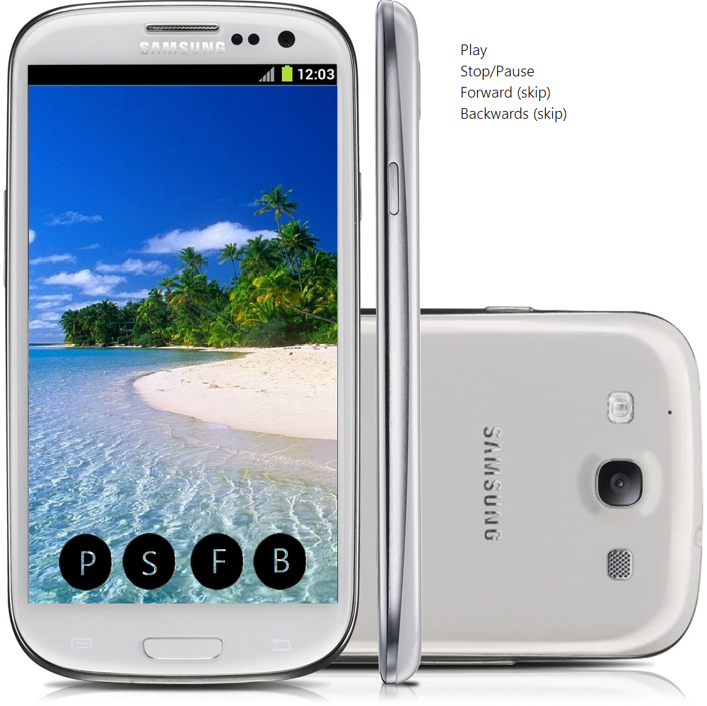

### Layout 2

4 buttons button – Play, Stop/Pause, Forward and Backwards (skip). Vertical - Taking into account if the user left or right handed.

